**DAILY ONLINE ACTIVITIES SUMMARY**

|  |  |  |  |  |  |  |  |  |
| --- | --- | --- | --- | --- | --- | --- | --- | --- |
| **Date:** | **02/06/2020** | | | | | **Name:** | **Hanan Saleem Baji** | |
| **Sem & Sec** | **4th SEM 'A' Section** | | | | | **USN:** | **4AL18CS024** | |
| **Online Test Summary** | | | | | | | | |
| **Subject** | | **N/A** | | | | | | |
| **Max. Marks** | | **N/A** | | **Score** | | | **N/A** | |
| **Certification Course Summary** | | | | | | | | |
| **Course** | **1. Cyber security** | | | | | | | |
| **Certificate Provider** | | | **1. Great Learning Academy** | | **Duration** | | | **1. 3 hour** |
| **Coding Challenges** | | | | | | | | |
| **Problem Statement:** 1. Write a Java program to find Perfect Sum Problem.  2. Given an array of positive integers. Write a C Program to find inversion count of array.  3. Write a program in java, an array of integer data to be initialized. During the initialization, if a user enters a value other than integer value, then it will throw InputMismatchException exception. On the occurrence of such an exception, your program should print “You entered bad data.” If there is no such exception it will print the total sum of the array.  .  For example | | | | | | | | |
| **Status: completed** | | | | | | | | |
| **Uploaded the report in Github** | | | | | **Yes** | | | |
| **If yes Repository name** | | | | | 1. <https://github.com/saleemhananbaji/C-coding> 2. <https://github.com/saleemhananbaji/Java-coding> | | | |
| **Uploaded the report in slack** | | | | | **Yes** | | | |

Certification Course Details: As the continuation of online course, I was able to complete the initiation of cryptography in Cyber security.

Snapshot:

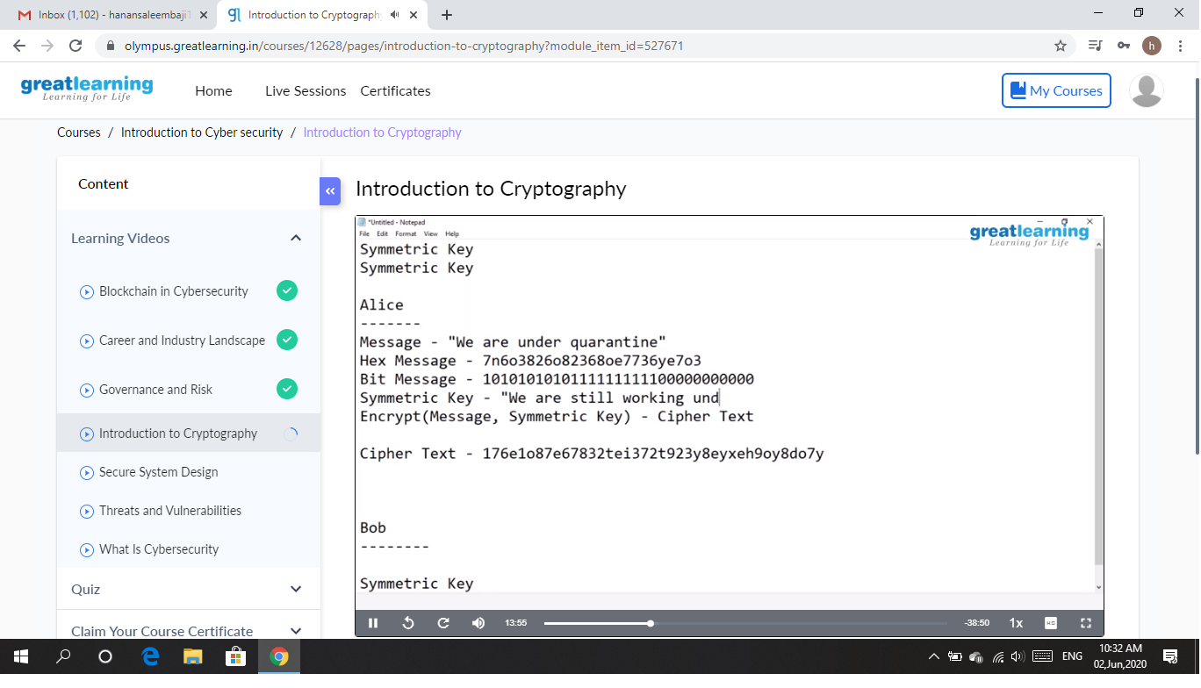

CODING CHALLENGES DETAILS: Problem statements

1. Write a Java program to find Perfect Sum Problem.

Solution: Uploaded it in github

Snapshot:

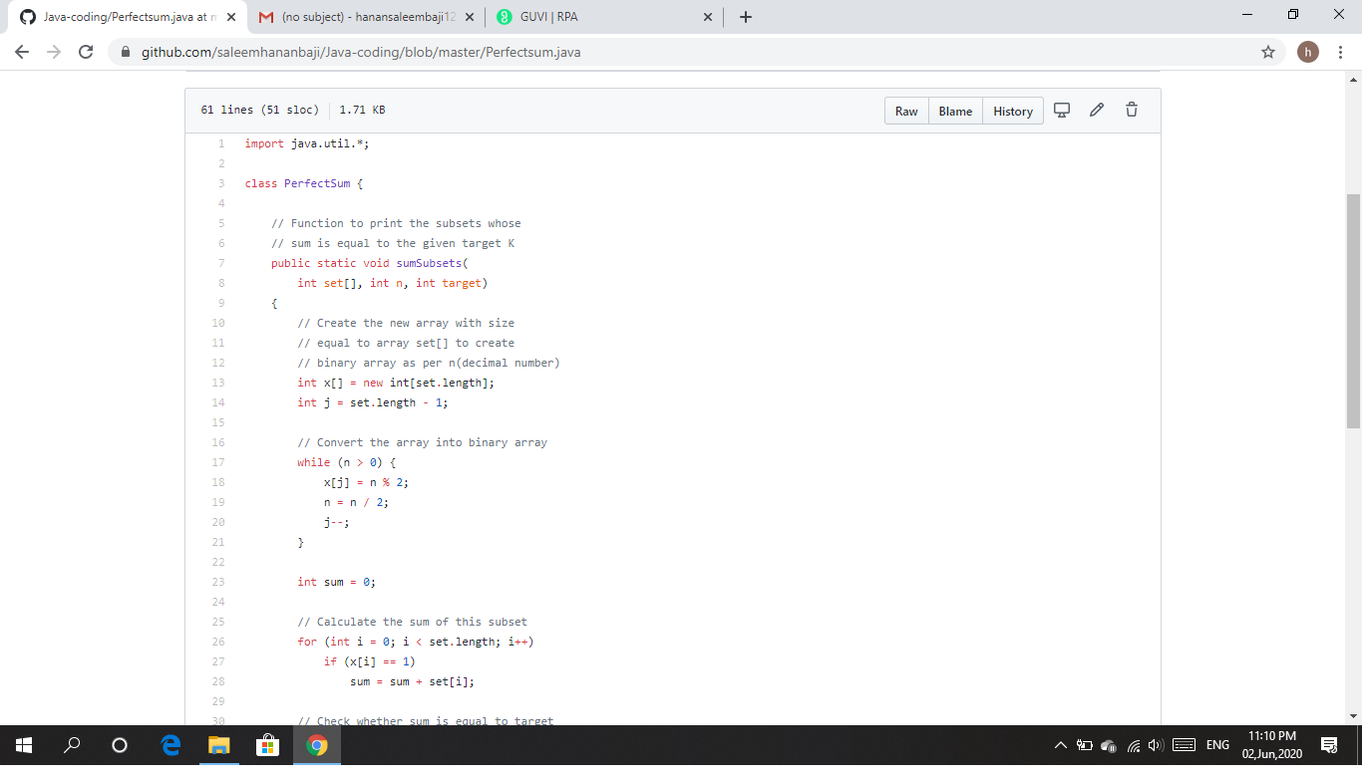

1. Given an array of positive integers. Write a C Program to find inversion count of array.

Solution: Uploaded it in github

Snapshot:

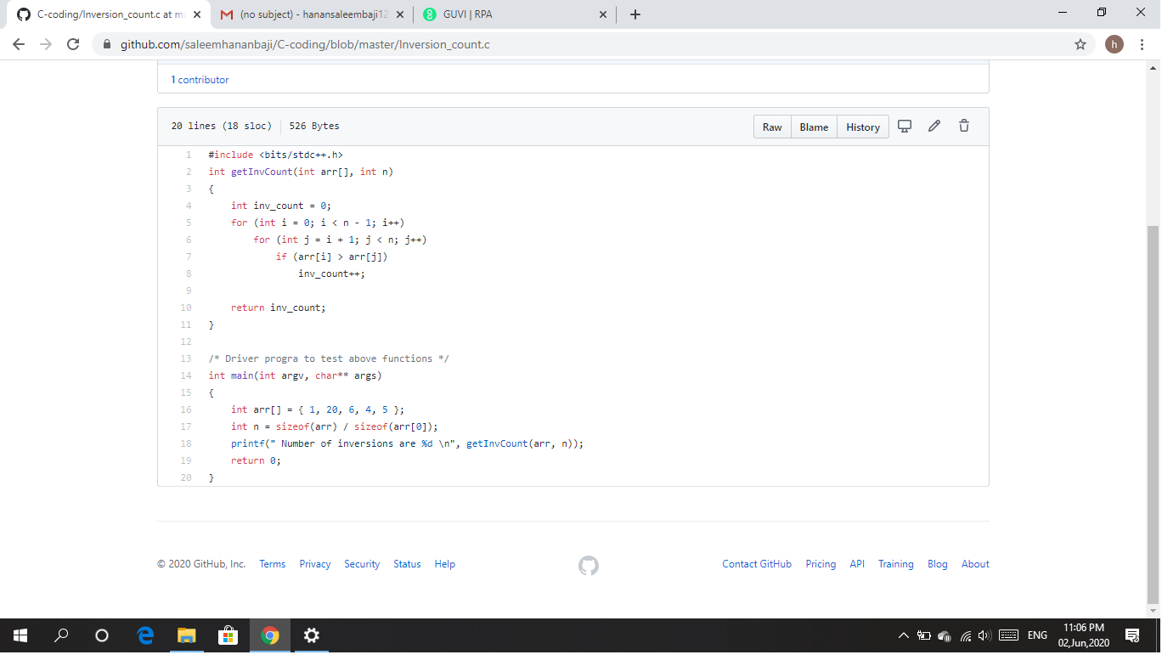

1. Write a program in java, an array of integer data to be initialized. During the initialization, if a user enters a value other than integer value, then it will throw InputMismatchException exception. On the occurrence of such an exception, your program should print “You entered bad data.” If there is no such exception it will print the total sum of the array.

Solution: Uploaded it in github

Snapshot:

